|  |  |  |  |
| --- | --- | --- | --- |
| **CHAPTER NO:** | **TABLE OF CONTENT** | | **PAGE NO:** |
| **1** | Abstract | |  |
| **2** | Introduction | |  |
| **3** | Problem Definition: | |  |
| **4** | Existing System | |  |
| **5** | Proposed System | |  |
| **6** | Literature Survey | |  |
| **7** | Requirements  Hardware Requirements:  Software Requirements:  Functional Requirements: | |  |
| **8** | Contents  Overview  Research challenges  Objectives  Scope of the project  Contributions |  | |
| **9** | System Architecture  Data Flow Diagram |  | |
| 10 | Python Libraries Used |  | |
| 11 | Steps involved in web scraping: |  | |
| 12 | Modules   1. Login Module 2. Validate the voice. 3. Speech to Text 4. Creating Dashboard for, 5. Compose a Mail 6. Read Inbox Mails 7. Read Sent Mails 8. Log out Page |  | |
| 13 | Techniques Used   1. Voice Authentication 2. Text to Speech Conversion |  | |
| 14 | Implementation |  | |
| 15 | Comparison of Existing and Proposed System |  | |
| 16 | Authentication and security |  | |
| 17 | Future Scope |  | |
| 18 | Conclusion |  | |
| 19 | References |  | |

|  |  |  |  |
| --- | --- | --- | --- |
| **CHAPTER NO:** | **TABLE OF CONTENT** | | **PAGE NO:** |
| **1** | Abstract | | 1 |
| **2** | International Economic Review | | 1 |
| **3** | Introduction | | 3 |
| **4** | Objectives | | 4 |
| **5** | Literature Survey   * Sharma and mittal in their study “prospects of   e-commerce in India”.   * Miyazaki and fernandez (2001) * Samadi and ali (2010) * Abhijit mitra * D.k.Gangeshwar * Martin dodge * Vijay govindarajan | | 5  6  7  7  7  7  8 |
| **2.1** | Research methodology:- | | 9 |
| **11** | Research Design: | | 9 |
| **12** | Sampling Design and Data Collection:- | | 10 |
| **13** | Statistical Tools: | | 10 |
| **14** | Data analysis:- | 10 | |
| **15** | Information Search | 11 | |
| **16** | ShopBots | 11 | |
| **17** | Branding and Uniformity among Products | 12 | |
| **18** | Branding and Distinction among Vendors | 12 | |
| **19** | The Role of Ignorance | 13 | |
| **20** | Research Focus | 15 | |
| **21** | Implications | 15 | |
| **21** | Customer Relationship Management (CRM) | 16 | |
| **23** | Patronage Loyalty | 17 | |
| **24** | Database Marketing | 17 | |
| **25** | Special Loyalty Programs | 18 | |
| **26** | Frequency Marketing | 18 | |
| **27** | Affinity Marketing | 19 | |
| **28** | Customer Lifetime Value  Corrective Action Plans | 19 | |
| **30** | Existing System | 22 | |
| **31** | Proposed System | 22 | |
|  | Scope of the Project | 23 | |
| **1.1** | Requirements   * Hardware Requirements: * Software Requirements: | 24 | |
| **32** | The functional requirements of the project are | 25 | |
| **33** | The non-functional requirements of the project | 25 | |
| **34** | Details of Technology | 26 | |

# **Voice Based E-mail for Visually Challenged People**

**Abstract:**

We have seen that the inception of the Internet has dramatically revolutionized many fields. The Internet has made the life of people so easy that people today have access to any information they want sitting in their homes. One of the main fields that the Internet has revolutionized is communication. When talking about communication over the Internet, the first thing that comes to our mind is E-mail.

E-mails are considered to be the most reliable way of communication over the Internet, for sending or receiving important information. But there is a special criterion for humans to access the Internet and the criteria is you must be able to see.

You must be thinking that what sort of criteria is this, everyone with eyes can see. But there are also specially-abled people in our society who are not gifted with what you have. A survey shows that there are more than 250 million visually challenged people around the globe. That is, around 250 million people are unaware of how to use the Internet or E-mail.

The only way by which a visually impaired person can send an E-mail is, they have to dictate the entire content of the mail to a third person (not visually challenged ) and then the third person will compose the mail and send it on the behalf of the visually impaired person. But this is not the correct way to deal with this problem. It is very less likely that a visually challenged person can find someone for help every time.

Although for these reasons specially-abled people are criticized by our society. So, for the betterment of society and giving equal status to such specially-abled people, we have come up with this project idea which allows the user to send mails using voice commands without the need for a keyboard or any other visual things.

In Our Project, the database is considered to be the main pillar of every project.

In our application, a database is used to store user details such as name, age, etc. The database here is also used to keep information about the emails sent or received or in the draft.

**Introduction**

Every human being is widely accessing knowledge, and information and also uses for communication through the internet. However, blind people face difficulties in accessing these net-based information, also in using any service provided through internet.

Due to its simplicity and accessibility, Internet is widely used in almost all the communication applications. In the recent times, number of application based on internet have been developed to make the communication as a more reliable and efficient in nature. Out of this numerous applications, E-mail is the most widely used and reliable way to communicate with each other.

The usage of e-mail is quiet easy and lucid for regular users but when it comes to the user with visual defect, the system is yet very difficult to use.

The current system is not useful for people with visual defect as the available system are based on the visual perceptions. There are huge up gradation in the technologies now a days, especially for the visually challenged people.

The advancement in computer based accessible systems has opened up many possibilities for the visually impaired across the worlds in a wide way. Audio based virtual environment like, the screen readers and many voice-based search engines have helped Blind people to access internet applications immensely.

The contribution made by this research has enabled the Blind people to send and receive voice-based e-Mail messages with the help of a computer.

**Artificial Intelligence for Speech Recognition:**

Artificial intelligence (AI) is a technology used for creating intelligent systems and machines that simulate human intelligence. Some artificial intelligence applications include various expert systems, natural language processing (NLP), machine vision and speech recognition. To understand and analyse human language such as English by extracting metadata from keywords, emotions, relations and concepts is Natural Language Processing

**Problem Definition:**

Problem Definition: The visually challenged people find it very difficult to utilize this technology because of the fact that using them requires visual perception. However not all people can use the internet. This is because in order to access the internet you would need to know what is written on the screen. If that is not visible it is of no use. This makes internet a completely useless technology for the visually impaired and illiterate people

**Existing System**

Simple e-mail systems are available in which only voice recognition & text-to-speech systems are accessible by remembering the keyboard shortcuts to access. The existing voice-based e-mail system has made use of IVR, Speech to text converter, Mouse click event and Screen reader. There will be a small icon of mic on who’s clicking the user had to speak and his/her speech will be converted to text format, which the blind people would see and read also, as in references.

**Disadvantages:**

User have to use mouse connected to the computer and should perform mouse click events to send and receive emails.

In existing system, they have chosen Web UI as the interface for system which is not easy for the impaired people to use

The existing mail services do not provide easy access to the visually challenged people because they are in written format or any type of attached information and there is no read out option to hear the mail that is received to their mail addresses.

One of the researches led to the development of an application that could help the user to send and receive mails in English language.

It was found that the proposed architecture performed better than the existing architecture at the time of this research. In that project, speech-to-text and text-to-speech conversion techniques were applied for providing easy access to blind people.

**Proposed System**

Because using this technology involves visual perception, it is extremely difficult for visually impaired persons to use it. This is because in order to access the internet you would need to know what is written on the screen, which is not possible by blind person.

In this proposed system it mainly concentrates on four different types of technologies Speech-to-Text (STT) this module collects the speech given by the user and converts to Text, Textto-Speech (TTS) this converts the response give to system to Speech, Chatbot for making the conversation more sense and for giving responses more like a human and finally, mail communication module for sending and receiving emails

**Advantages**

* Doesn’t need any mouse click events to send and receive emails.
* Purely based on the voice commands given by the user.
* Chatbot is used to make the conversation smooth and more like a human response.
* User friendly (as Blind person can easily use web based application).
* Easy Storage of data.
* More efficient.
* Requires less effort and time.
* The system that we are developing is entirely different from the existing ones. Unlike other systems which focus only on a particular set of people, our system is focused on visually challenged people too.
* It also helps handicapped and illiterate people.

**Literature Survey**

In this section, we provide a comprehensive review of the literature on the existing related technical issues. In [2], and in a voice of the architectural email, it is proposed that it helps blind people access the email. The current system is not blind, as it does not give a sound opinion about the reading of its content. The proposed system uses speech recognition, Interactive voice response, and a click of the mouse. In addition, for added security, the purpose, the device is used to authenticate the user. The first module will be registered in the system. This module will collect all of a user's information and tell them what information you will enter. In the second module, the login module, the system prompts the user to enter a user name and a password. Do this with the help of voice commands.

To perform the voice of the check, you will need more tests and voice. The user is then redirected to the inbox page after the registration has been completed. Once you have logged in, the user can carry out the normal operation of the mail system. System Settings: How To Create Email Account, Email, It's Trash. The user can switch between them with the help of voice commands. The paper proposes a system that relies on a system with a voice command, based on that, in contrast to the pre-existing email system. The whole system is, in essence, is based on converting the number to text. Once made use, the implementation of the system will prompt the user to speak commands to make use of the relevant services. If the user wants to access the relevant services, it is necessary to state that this command will work. This program uses the IMAP (Internet Message Access Protocol). This is a standard Internet protocol used by an email to send an email from a mail server over TCP / IP. The main type of activity, the screen, will be the first screen displayed from the beginning of the year. On this screen, waiting for the user to press a single button, and the system will start to receive your voice commands. It's a full-size single button to tap anywhere on the screen. Then, with the help of voice commands, the user can send an email to read it. In [4]. the system uses three main technologies:

● To convert the number to text

● Text-to-speech.

**Interactive Voice Response.**

When you are visiting the site for the first time, it needs to register with the help of voice commands. Also, once you register, the user's audio data and a note will be saved in the database. And the user will receive a user id and password after the user logs in to receive an email in such a system. The user interface has been developed with the help of Adobe Dreamweaver CS3. The site is primarily centered on the concept of efficiency and effectiveness. In addition, there is a "Contacts" page, where the user can offer any suggestions or any help if they need it. At the time, one of the e-system is proposed, which is easily accessible for the blind. You can use the voice-to-text converter-text-to-speech converter and the Viterbi algorithm. The algorithmic rule, which is working with the technology, does not find it to be the most appropriate word; as soon as the user says so, so it is, as your guessed word, for a given the word pronounced. The user registers at the site where they are for the first time, the visit to the site. This system will reduce some of the disadvantages of the current system. Sorry, this scheme is the efficiency of the Viterbi algorithm to reduce the number of errors will increase and require more space. a system for the blind and the illiterate is proposed to improve their interaction with the email system. This system eliminates the use of IVR technology that are using screen readers, Braille keyboards. There, we used the speech-to-text and text-to-speech conversion. Voice commands are also used for other activities as well. For registration, you may use your identity, your email address, and your password. This is functionality to use the function that tells PHP to email. This is the library, which you can use to send an email. To obtain the user's email from the IMAP server. This Lash-Morris-Pratt algorithm is used to search for email collection boxes. Thus, the system's environment is clean, the voice-controlled by a feedback system in each step. Sorry, this scheme is that it uses Gmail as a host server so that we can make use of other email services like Yahoo, Google, etc. Proposed a voting scheme, which is based on the PCs and mobile devices for the blind. They are the most important elements found in the system's work in the note below.

1. G-mail system messages, refer to the buyer's email.

2. RSS-Real simple syndication news

3. Let's listen to the music

4. The system's red book and reader

5. Search for your discs and folders using the bridge's Browser.

It is a software architecture used for the blind, with easy access to the email and MMS messaging functionality into the operating system. The graphical user interface design can be achieved with the help of voice commands and a mouse, but with the help of the keyboard. RSS feeds are also used along with email, which is simple syndication to distribute a list of headlines, announcements of new products and services. We have also prepared an application for you. Along with email, other apps can be accessed by using a voice command. the authors propose the Tetra-Entry, a blind-friendly email client, to overcome the favourability and the convenience of email activities.

The number of blind people is rapidly increasing, so the research's main goal is to develop a simple, inexpensive, user-friendly, and compact device that allows visually impaired people to use multimedia applications of operating systems such as text, music player, and dialing system by integrating a GSM module.All of the forementioned features are included on a low-cost Raspberry Pi board. At the period, [16], one of the E-Systems that is easily accessible to the blind is proposed.

You can use the Viterbi method, as well as the voice-to-text and text-to-speech converters. The computational rule that works with the technology does not determine it to be the most acceptable word; yet, as soon as the user says it, it is spoken as your guessed word for a particular word. The user creates an account on the site that they are visiting or the first time. This system will mitigate some of the present system's drawbacks. Sorry, but the Viterbi algorithm's efficiency in reducing the number of errors will increase, requiring more space.

A solution for the blind and illiterate to better their interaction with the email system is proposed in. This technique eliminates the need for screen readers and Braille keyboards while using IVR technology. Speech-to-text and text-to-speech conversions were utilised there. Voice instructions are also employed for a variety of different tasks. Your identity, email address, and password can all be used to register.This is the ability to use the function that instructs PHP to send an email.This is the email library from which you can send an email.The IMAP server is used to retrieve the user's email.To find email collection

**Voice Based Technology for Blind**

Pranjal Ingle et al.(2016) [1] , used three types of technologies to create the application namely STT(speech-to- text) where the speech is converted to text,TTS(text-to- speech) to convert the text to speech,and thirdly IVR (interactive voice response) which describes the interaction between the user and the technology in many ways like keyboard or voice message. It also allows the user to interact with the mail system. The main disadvantage includes the usage of high sensitive mics which are mostly not available to all the users Jain. V. et al., (2021)[2] ,this research proposes a voice- based email system that visually impaired people can use to easily access email. With the aid of technology, this initiative aims to assist people who are blind in sending and receiving voice mails. The advancements in text-to-voice email delivery for people who are blind or visually impaired are the main topic of this study. This study offers a text-to-voice and voice- to-text email access method for those who are blind. This enables persons who are blind to send mail using voice control instead of a keypad.

Divesh Jethani et al.,(2018)[3] proposed a voice based system for the visually blind with multi-lingual facility,the system provides a good GUI for all types of users. The user will be able to send,receive,read,delete the mail from the mail system. But the main disadvantage includes the usage of mouse clicks, which is necessary at some places of the proposed application.

Dr.S.Brintha et al.[4], proposed a system with TTS and STT to read and record symbolic linguistic representations like phonetic transcriptions. The architecture of the system includes two modules namely interface selection and mailing option, the first module selects the type of users that is blind user or sighted user. And the second module includes the simple mailing options to perform all tasks.

Parkhi Bhardwaj et al.,(2016) [5], uses an extra speech recognition technology along with all other converters and IVR to develop the application. The proposed system provides more features than existing GUI. Java was the core programming language used. The application can be used by all types of handicapped people and illiterate people.

**1. Summary of the Literature survey**

In literature survey various technology to develop a voice based E-Mail system was discussed. Since the existing system like screen readers and so on, has some disadvantages. The proposed work in this model takes the best advantage of technology to use features which has the highest accuracy in capturing voice and displaying contents which are needed by the visually impaired people.

**Requirements**

* **Hardware Requirements:**
  + - Intel Processor
    - At least 2 GBRAM
    - At least 60 GB of Usable Hard DiskSpace
    - Microphone and Speaker
* **Software Requirements:**
  + - Python3.xss
    - Pip to install Packages
    - Pycharm Community Edition
    - WINDOWS Operating System

**Functional Requirements:**

The input/output in this software is in the form of forms, speech, and gestures. The data is saved in tables in a database, which is where the storage process takes place. The computation is done via queries, APIs, and procedures that are designed to take as little time as possible. The user will initially register with the system so that he or she can log in later, similar to how a naive person would do with an existing gmail account. After successfully registering and logging in, the user will be sent to the main menu, which includes operations like as compose, inbox, and trash. After selecting a specific operation, the user will finish the operation by performing the related activities.

Finally, the API will conduct tasks by connecting to Google's email account. The data flow diagram depicts the flow of a set of data in accordance with a specific information system paradigm.It's used to sketch out a data system's design and structure without providing processing time alternatives in order, such as yes or no choices in traditional flow chat time.

**Contents**

Although our culture blames those who are blind for these reasons. The visually impaired may now use the Internet thanks to a range of dependable and efficient technology. As a result, we have developed this design concept for a voicemail system that is email-friendly and can be used by an eyeless person in order to advance society and grant similar especially suitable people an equal status and respect. This gives blind people the ability to send and receive messages using voice commands. Other visual enhancements or a keyboard are not necessary for this system. This is based on the usage of STS and TTS transformers, or speech to text and text to speech, respectively, for translating spoken words into written and audible forms. The person utilizing this method wouldn't have any prior knowledge of the keyboard's layout, the alphabet's positions, or the locations of the keys.The user will respond after being automatically fed voice commands to carry out certain actions by the system. The user merely needs to correctly follow the directions that the system offers. With the use of voice commands and the suggested technology, visually impaired persons might access emails on their own.

**Overview**

The internet has become as one of the desired or practical things for daily life. By gaining access to information, facilitating interpersonal interactions, and growing enterprises and associations, it has made people's lives more comfortable. Internet becomes the first luxury for a 24-hour lifestyle. everyone who uses the data and information on the internet. People's lives are made simpler when they use the internet for communication. Internet has significantly altered the realms of communication. Global e-mail drug users were four billion in 2021, and the figure is expected to rise to 4.6 billion by 2025.In 2021, there were over 306 billion emails sent and received per day globally. For sharing and inputting sensitive or private information, electronic correspondence communication has shown to be the most secure and safest method. To utilise the Internet, a person must meet the prerequisite of being able to see, which is a need that must be satisfied. Because surfing the internet involves visual sense, it has become a scourge for those who are visually impaired. More than 250 million individuals, according to a check, do not know how to use email or Internet installations for communication.The only way an eyeless person can utilise all these internet features is if they dictate the entire material to a third party who isn't visually impaired. The third party will then send, receive, and read out the messages at the visually impaired person's request. Although the average person assists the blind in accessing their mail, that isn't the best method to approach the problem. Because the visually impaired individual demands assistance whenever he or she can find it.

**Research challenges**

Emailing doesn't provide a large challenge to individuals with the gift of sight, but since it interferes with so many work obligations, it presents a considerable challenge to those without the gift of sight. Emails with audio attachments are only preferred by those without eyes. They can easily reply to the spoken commands. Therefore, there are less odds of making this audio-based email available to those who are blind. For those without eyes, this voice-based email system is helpful since it enables them to understand their location.On the other hand, people need to remember mouse clicks and keyboard shortcuts. With this method, the usability of all users, including those who are typically blind, is given more priority. Only desktop computers may use this system, and occasionally it I s unable to properly decode the material. Future updates to the system's UI may also include new functionality.

**Objectives**

The major goal of this article is to create a voice-based emailing system that will enable visually impaired and illiterate persons to use everyday technologies like sending and receiving emails and accessing the internet. With the use of this method, blind users may easily log in by speaking. The primary goal of developing the sort of system outlined in the study is to increase the sense of community among those who are blind or visually impaired. Any user of any age may easily access our email system. In the future, this technology may be improved and used for additional services, such as texting and using voice commands to operate other applications, in addition to email

**Scope of the project**

The development of computer-based accessible solutions has given the blind and visually impaired many new opportunities all around the world. However, because utilizing them involves visual sight, visually impaired persons find it extremely difficult to utilize this equipment. The weaknesses of the current system are remedied by the proposed system. In contrast to the current systems, the proposed approach is voice command anchored. The availability of the suggested system is the most crucial factor that has been taken into consideration. Since the present system is completely different from the one we're designing.

Python is used to implement the requested task. Ideas focuses on providing basic features like create, read, transfer, and read emails as well as voice-based instructions. Unlike the existing system, which places a strong emphasis on user friendliness and compatibility. By using this system, the user is prompted to give the system certain commands, such as "compose the mail," "display the email id of the previous three unread messages," and "select one mail id" before reading the topic and content of that particular email id. Direct user- system interaction is used. Our method is favourable to all sorts of individuals, whether they are normal, visually handicapped, or illiterate, whereas the current system concentrates more on normal people.

**Contributions**

**Our contributions are summarized as follows:**

1. The STT (Speech- to- text ) module , converts the speech recognized through microphone to the text and stores the written formattext in the variable. Or else, it throws an exception.
2. The TTS (text to speech ) module converts the text given to that function to the audio that is .mp3 file and plays the file created .
3. GTTS (Google text to speech) library in python .This is platform independent that is it is compatible with Windows, Linux, and MacOS speech library. This module which automatically produces an audio file while accepting the input which is in text format along with language and speed parameter. And also read out the messages in emails for the user.
4. SMTP (Simple mail Transfer Protocol) module is imported using the keyword smtplib. It is used to connect the Gmail This protocol is demanded to compose the emails and act as a connection to Gmail helping in performing other functions also.

**System Architecture**

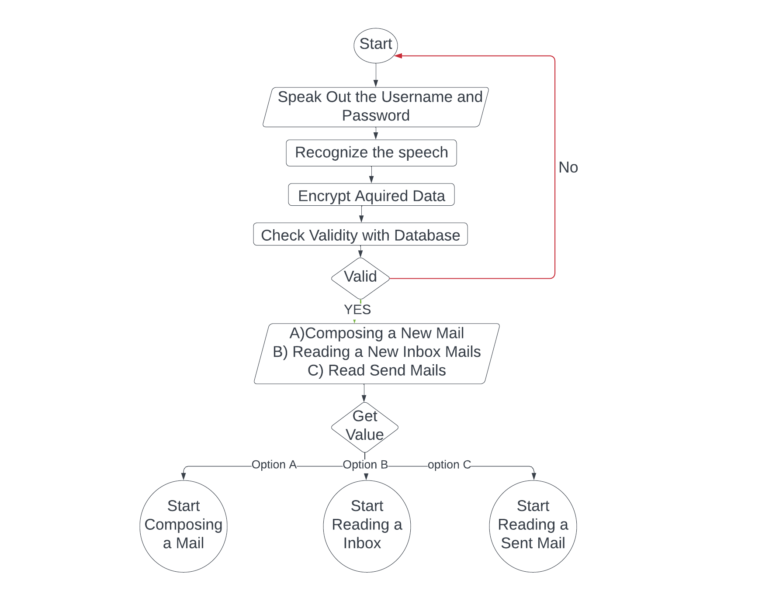

**Data Flow Diagram**

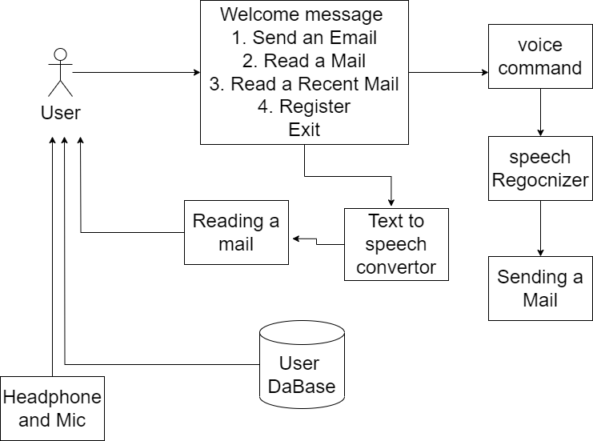

**Python Libraries Used**

The prose system speech_recognition package from python library which is installed using the pip command. Speech Recognition it is an important feature in several day- to-day application used in home application and many artificial intelligence etc. SMTPlibis another important package which is used to send mail from the sender mail address to the receivers mail id. The text to speech is done using a module called gTTS from google-text-to-speech. Pythons client side library called imaplib is used for accessing emails over IMAP protocol. It allows the client program to manipulate the email message. For providing a good interface for user tkinter and pyglet is imported which provides functions for developing interface for multimedia application.

**List of Python Libraries**

1. SpeechRecognition
2. Pyglet
3. Beautifulsoup4
4. gTTs
5. Pyaudio

**Speech Recognition**

**Speech Recognition** is an important feature in several applications used such as home automation, artificial intelligence, etc. This article aims to provide an introduction to how to make use of the Speech Recognition library of Python. This is useful as it can be used on microcontrollers such as Raspberry Pi with the help of an external microphone.

### Speech Input Using a Microphone and Translation of Speech to Text

**Configure Microphone (For external microphones):** It is advisable to specify the microphone during the program to avoid any glitches. Type **lsusb** in the terminal for LInux and you can use the

**Piglet**

**Pyglet** is easy to use but powerful library for developing visually rich GUI applications like games, multimedia etc on Windows, Mac OS and Linux. This library is created purely in Python and it supports many features like windowing, user interface event handling, Joysticks, OpenGL graphics, loading images, and videos, and playing sounds and music. pyglet is provided under the BSD open-source license, allowing you to use it for both commercial and other open-source projects with very little restriction.

#### Features

* **No external dependencies or installation requirements:** For development of most of the applications, pyglet does not need any external libraries or installation of packages which helps in simplifying distribution and installation
* **Take advantage of multiple windows and multi-monitor desktops:** Sometimes multi-monitor desktop setups are use for game development and pyglet is designed in such a way that it lets you use as many windows as needed and also allows fullscreen games and application across multiple screens.
* **Load images, sound, music and video in almost any format**
* **pyglet is provided under the BSD open-source license**, allowing you to use it for both commercial and other open-source projects with very little restriction.
* It supports development in Python 2 as well as Python 3

**Beautifulsoup4**

**There are mainly two ways to extract data from a website:**

* Use the API of the website (if it exists). For example, Facebook has the Facebook Graph API which allows retrieval of data posted on Facebook.
* Access the HTML of the webpage and extract useful information/data from it. This technique is called web scraping or web harvesting or web data extraction.

This article discusses the steps involved in web scraping using the implementation of a Web Scraping framework of Python called Beautiful Soup.

**Steps involved in web scraping:**

1. Send an HTTP request to the URL of the webpage you want to access. The server responds to the request by returning the HTML content of the webpage. For this task, we will use a third-party HTTP library for python-requests.
2. Once we have accessed the HTML content, we are left with the task of parsing the data. Since most of the HTML data is nested, we cannot extract data simply through string processing. One needs a parser which can create a nested/tree structure of the HTML data. There are many HTML parser libraries available but the most advanced one is html5lib.
3. Now, all we need to do is navigating and searching the parse tree that we created, i.e. tree traversal. For this task, we will be using another third-party python library, [Beautiful Soup](http://www.crummy.com/software/BeautifulSoup/). It is a Python library for pulling data out of HTML and XML files.

**Gtts**

There are several APIs available to convert text to speech in Python. One of such APIs is the Google Text to Speech API commonly known as the gTTS API. gTTS is a very easy to use tool which converts the text entered, into audio which can be saved as a mp3 file.

The GTTS API supports several languages including English, Hindi, Tamil, French, German and many more. The speech can be delivered in any one of the two available audio speeds, fast or slow. However, as of the latest update, it is not possible to change the voice of the generated audio.

**Pyaudio**

Pyaudio is a Python binding for PortAudio, a cross platform library for input and output of audio. This basically means that we can use Pyaudio to record and play sound across all platforms and Operating systems such as windows, Mac and Linux.

**Modules**

1. Login Module
2. Validate the voice.
3. Speech to Text
4. Creating Dashboard for,
   * + Compose a Mail
     + Read Inbox Mails
     + Read Sent Mails
5. Log out Page

**Description**

1. **Login Module**

This will help users to login into the system using their Mail id and password. A user who has the valid id and password can only log in to their respective accounts.

It will help the authentication of the user who enters the system. The module provides a layer of security over the system as only authorized personnel can login into the system.

This prevents any anonymous person to enter the system and mishandle the records. It is better than the manual method as they do not have any security measure of who can access the system and who cannot.

* These is the first modules of the system. Any user wishes to use the system should first register to obtain username and password. Once registration is done the user can login to the system. This module will ask the user to provide the username and password. This will be accepted in speech. Speech conversion will be done to text and user will be told to validate whether the details entered are correct or not. Then database will be checked and if the user is authorized it will be directed to homepage

**Forgot Password**

In case where an authorized user forgets the password and thus is not able to login he/she can select forgot password module. In this module the user will be first told enter username. According to username security question will be searched in database. This is the question provided at time of registration. The question will be spoke out by the computer. The user should in turn specify the answer that was provided by him/her during registration. If both get matched, user is given option to change password.

**Registration:** For new user who wants to use this system are first required to register themselves into the system. In the registration page, username, gender and address fields are to be filled by the user.

After filling all the details, a face recognition process will start which will capture user faces which will be used at time of login.

Normal and Differently abled people can fill the details by using keyboard and mouse control and then click Register button to register themselves and Visually Impaired people are required to use Speech recognition process to fill the details.

When user click register button or speak register then before registering all the details into the database a face detection and collection of sample process will start which will collect user samples.

**Login:** In Login phase, first a face recognition process will start which will try to identify the user, if the user is identified then he/she will be redirected to the Home page and if the process fails to identified it as authenticated user then system will ask user to provide his/her credentials.

Here process identifies the user, so ser will be redirected to the home page but if the process fails then below screen

will appear where user will have to speak their username and password.

**Home Page:** Once the user logs into his account, he/she will be redirected to Home Page where there are several options like Inbox, Compose Mail, Sent Mail and Logout. Normal People and differently abled can click to the respective buttons to use the service but for visually impaired they have to speak which service they would like to use.

**2. Validating a Voice**

Voice authentication is an identity authentication technology that verifies a user based on their unique biometric characteristics.

It’s secure, fast, and can be applied across several fields like mobile applications, IoT devices, and call centers.

The advancement in neural networks over the past few years has enabled the development of faster and more accurate voice authentication systems.

In our Project, we use this technique to check whether the user is authorized person or not to ensure a security.

A person’s voice is extremely difficult to forge for biometric comparison purposes because of its inherent uniqueness like dialect, speaking style, and pitch.

**3. Speech to Text**

After authenticate the Uername and password which is entered by the user

That Speech is converted to the text to get login with the google mail.

We use SpeechRegcoginiton module in python do achieve the process speech to text.

Speech to text is a speech recognition software that enables the recognition and translation of spoken language into text through computational linguistics. It is also known as speech recognition or computer speech recognition.

Specific applications, tools, and devices can transcribe audio streams in real-time to display text and act on it.

After authorization of the user voice then,

* + The user is redirected once logged in and following can be performed once logged in.
    1. Inbox
    2. Compose
    3. Sent Mail
    4. Trash

**1. Compose Mail**

This is one of the most important options provided by the mail services. The functionality of compose mail option would not match the already existing mail system. Since the system is for visually challenged people and keyboard operations are completely avoided composing mail would only be done on voice input and mouse operations. No typed input will be required. User can directly record message that needs to be propagated and can send it. This voice massage will go in form of attachment. The receiver can hear the recording and get the message user wanted to send. User would not require attaching the file. Record option will be provided in the compose window itself. Once recorded it will confirm whether the recording is perfect or not by letting the user hear it and if the user confirms it will be automatically attached to the mail.

**2. Inbox**

This option helps the user view all the mails that has been received to his/her account. The user can listen to mails he/se wants to by performing the click operation specified by the prompt. In order to navigate through different mails prompt will specify which operations to perform. Each time the mail is selected the user will be prompted as whom the sender is and what is the subject of that particular mail. Accordingly user can decide whether the mail needs to be read or not or it should be deleted. Deleted mails will be saved in trash section.

**3. Sent Mail**

This option will keep a track of all mails sent by the user wants to access these mails, this option will provide them with their needs. In order to access the sent mails user will need to perform the actions provided by the prompt to navigate between mails. When the control lands on particular mail user will be prompted as who the receiver was and what is the subject of the mail. This will help the user in efficiently understanding and extracting the required mail.

**4. Trash**

This option will keep track of all deleted mails deleted by the user. Deleted mails could be the ones from inbox or sent mail. If at any time the user needs to retrieve a mail which was deleted it can be done from this option.

After the successful login , the email system asks for the option whether the user wants to compose a mail or wants to check the inbox . To compose a mail user need to press ENTER . To check Inbox user need to press the space bar .

This module is developed using a menu-driven type of program in python, the program ask the user to press Enter to compose a mail or ask the user to press Space bar to check the inbox of the email id of logged in by the user.If the user press the Enter , call the compose_mail() function to compose a mail.If the user press the Space bar , call the check_inbox() function to check the inbox of the logged in mail id by the user.The front-end of this module is also developed using tkinter GUI module.

1. **Creating a Dashboard**

A dashboard is a way of displaying various types of visual data in one place. Usually, a dashboard is intended to convey different, but related information in an easy-to-digest form.

And oftentimes, this includes things like key performance indicators (KPI)s or other important business metrics that stakeholders need to see and understand at a glance.

Dashboards are useful across different industries and verticals because they’re highly customizable. They can include data of all sorts with varying date ranges to help you understand.

We created the dashboard to give knowledge to the user what are all the features they can have.

1. **Logout Page**

This will log out the mail for the user’s security.

**Techniques Used**

**1. voice Authentication**

**Voice authentication** or voice recognition is a biometric authentication technology that enables users to access online services using speech.

In other words, voice biometrics is the science of using a person’s voice as a unique identifying biological characteristic.

Often, voice characteristics are measured using liveness detection or prompting the user to speak a unique phrase for the current transaction. It can also be measured passively — the user doesn’t have to speak a required phrase knowingly.

**Types of voice authentication**

Here are two key types of voice authentication methods:

**A. Text-dependent**

As the name suggests, text-dependent authentication depends on the **words** a person is speaking. This sequence of words is often system-generated and referred to as a “voice passphrase.”

Typically, a voice passphrase is three or four words long and takes 1.5 seconds to speak the words. However, you can choose randomized numbers too.

Text-dependent authentication is an active authentication method, which means the speaker must knowingly perform the enrollment or speak the required system-generated phrase.

Such authentication mechanisms are built for fraud prevention as the probability of a potential imposter to record the victim’s voice speaking the exact passphrase is low.

Voice-based mobile or web login or verifying customer identity through IVR authentication are some great examples of text-dependent authentication.

**B. Text-independent**

This voice biometric authentication method performs voice verification without the constraint on the speech content.

Compared to the text-dependent method, text-independent authentication is more convenient as the user can speak freely to the system. However, it will require longer training and testing utterance samples to achieve more accurate performance.

Text-independent verification can be used in [call centers](https://www.timedoctor.com/blog/how-to-start-a-call-center/) where the customer could say anything while interacting with an agent or IVR (Interactive Voice Response), enabling speaker identification in the background.

Let’s now take a detailed look at the mechanism behind speaker verification.

**Working of Voice Authentication**

Voice recognition systems enroll a person by creating an initial template. It’s often the result of merging several templates from samples of that person’s speech for greater accuracy.

The initial template is called the **enrolment template**or enrolment voiceprint. The authentication tool stores these templates in secure databases.

Depending on the method of authentication (text-dependent or text-independent), a voice biometrics tool collects a user’s voice template.

However, it doesn’t authenticate what the person is speaking — it only checks who is speaking.

It extracts the characteristics that distinguish a person’s speech from other people. The result is a voiceprint or voice template, analogous to a fingerprint.

A person’s voice is extremely difficult to forge for biometric comparison purposes because of its inherent uniqueness like dialect, speaking style, and pitch.

This simply means that even if a voice impersonation sounds similar to the human ear, a detailed analysis of the voiceprint done through computer algorithms can help distinguish it from the sample.

Over 70 body parts, each with a unique size and shape, contribute to how a person speaks.

Voice biometrics relies on voice characteristics that strongly correlate to the physiological qualities of how a person creates speech.

Now that you know all about voice authentication and how it works, let’s check out some of its real-world applications.

Voice authentication is a type of security authentication that relies on a person’s unique voice patterns for identification in order to gain access.

This type of authentication requires a device that can capture a person’s voice very accurately and software that can recognize the patterns of the voice and compare it to already-recognized patterns.

Voice authentication relies on a person’s unique voice biometric, which is the digital or numerical representation of the sound, rhythm, and pattern of a person’s voice, which is as unique as his/her fingerprints or iris patterns.

Voice authentication is also known as voice biometrics, voice ID, or speaker recognition.

**Uses of Voice Authentication**

**1.** **Mobile applications**

Voice authentication’s primary consumer-facing use case is hands-free **mobile authentication**. All you need to do is provide a voice command to log in or authorize purchases, eliminating the need to memorize logins and passwords.

This is ideal for mobile phones or other settings where face recognition and other forms of biometric authentication can be inconvenient.

Additionally, voice authentication can also be useful for [virtual assistant solutions](https://www.forbes.com/sites/cognitiveworld/2019/12/09/how-an-ai-powered-digital-assistant-increases-productivity-in-business/?sh=627863886281) such as Google Home, Amazon’s Alexa, and Siri. You can use it to place orders and perform other functions that require some authentication.

**2.Calls centers and IVR systems**

Outdated security methods like traditional passwords or questions are no longer secure enough.

Voice biometrics systems offer resistance against voice mimicking through intrinsic algorithms used for biometric analysis and offer a blocklist. This makes the technology especially helpful in the call support industry.

You can also use speaker recognition as an authenticator during customer support calls. Callers may find this more convenient and secure than sharing personal data such as their license or credit card number for identity verification.

### 3. Web applications

You can add voice verification systems to web pages or applications in the banking and e-commerce sectors. Voice authentication in web applications can be helpful in the remote identification of users.

Additionally, passive enrollment or text-independent authentication makes it easy to onboard new users for your service without any registration. Customers are automatically verified in real-time while interacting with an IVR or contact center agent.

### 4. Internet of things (IoT)

IoT applications offer new and innovative ways for communication and interaction between humans and machines.

Proper implementation of voice authentication can provide a more flexible user experience than traditional methods like touch screens.

And as voice authentication can provide an added layer of security, you can easily access your IoT home device without any concerns.

Clearly, voice biometric authentication seems to make things a lot easier.

However, before you decide to use voice authentication for your business, let’s take a look at its benefits and challenges.

**Challenges of Voice Authentication**

### 1. Authentication through audio deep fakes

The recent advancement in artificial media technology has allowed people to create **deep fakes**. These are synthetically produced fake voices of a person, identical to their original voice.

Deep fakes are becoming more common and may make an AI program believe in its authenticity.

**So how do you prevent unauthorized users from entering the database?**You can create an allowlist of voiceprints and store them in an active directory. During this process, the voice recognition system enrolls the user into a list of allowed members.

So, each time a user tries to access the system, their voiceprint is compared against both the allowlist and a blocklist of fraudster voiceprints.

And while the authentication is underway, passive fraud detection can send alerts if the voiceprint matches against the blocklist database.

### 2. Lack of accuracy

**Background noise**is one of the major factors that affect automatic speech recognition. It can impact the quality of the speaker’s voice template and, in turn, decrease the accuracy level of the authentication process.

A voice authentication system may not be able to differentiate between your speech, other people talking, and ambient noise — leading to transcription mix-ups and errors.

This means it can be challenging to use voice authentication in noisy environments like busy offices or public spaces.

For seamless authentication, you can use close-talking microphones or noise-canceling headsets that enable the software to focus on your speech. And while you can ensure this in a business setting, not every customer can have access to such gadgets or a quiet environment.

### 3. Text to Speech Conversion

Text to Speak is one of the excellent and most popular features of multiple online sites today. It is usually called TTS technology, which instantly speaks the entire textual content that a user puts into a TTS online tool.

Text to Speech is the latest technology that can read online or digital text clearly and in a louder tone. The technology scans the written texts on computer screens or on any electronic device’s screen and instantly converts the text into a spoken form.

Text speech technology is really beneficial, especially for the visually challenged people who are working. This technology helps them in learning education and getting knowledge easily. Now it is also used as a basic source in the global educational system.

### 3. Speech To Text Conversion

* Speech-to-text is a speech recognition software that enables the recognition and translation of spoken language into text through computational linguistics. It is also known as speech recognition or computer speech recognition. Specific applications, tools, and devices can transcribe audio streams in real-time to display text and act on it.
* There are two main types of speech-to-text technology:
  1. **Speaker-dependent**: Mainly used for dictation software.
  2. **Speaker-independent**: Often used for phone applications.
* These two speech recognition systems rely on software and services to function adequately, with the main type being built-in dictation technology. Many devices now have built-in dictation tools, such as laptops, smartphones, and tablets

**Experimental Setup**

**A. Speech-to-Text-with-artificial intelligence**

To turn off the sound and text can be transformed into a light, easy-to-use API for strong, up-to-date, and neural network models, which the Google Cloud Speech-to-Text software developers provide. The API is available in one hundred and twenty languages, supporting a global user base. You can change your voice and the sound of the transcript of the center's decision, and so much more. Unfortunately, this is a regular stream or pre-recorded audio, which is a poorly-handled by Google's machine learning methods.

**B. Text to speech unification It is an automatic text-to-speech.**

This technique is very similar to a human verbalizer, to say that it's a text. TTS (text-to-speech) is a technology that enables portable computers to communicate with you. Here are some great examples of the text-to-speech engine used for primary, text-processing, and synthesis. The engine will usually trigger the sound-and-audio format, the output control.

**C. Structure of a text-to-speech unification system**

The stages included in producing the synthesis of * the text are perceived to be TTS and reviews to turn the tide, speak with an accent, and create prosody. You can do with prosody at that time. Apparently, according to the information currently available on the market, it will be the one ring. With the unity of the periodic structure, the synthesis can be reduced to its most important modules.

**D. Processing of language processing**

At the side of prosody, it generates a written text of the scanned text.

**E. Digital Signal module processing**

It converts representative data from information science into speech that can be heard and understood. The following are the operations of the Processing of Natural Language module: Text summary: The text is first separated into tokens. How to convert a token to the letter, but also the token type of the notes. For a token of the type "G", If "the record is composed of the extension, an additional" 11 "tokens, to be able to play in the wild," in", and "1979" is transformed into "ten, nine, eight, seventy-nine. To apply the pronunciation rules: Apply the pronunciation rules, in which case the text of the analysis is finished. The letters cannot repeat from 1: 1 to the phoneme because it does not fit, it is always parallel to each other. In some environments, characters that do not conform to the audio at any time (for example, in", " is "learned" or phonemes (the "n" and "popular"). Also, a lot of this message is to vote in favor of the rights (the "ca" and "god"). The Prosody Generation: Prosody is created, and then to a lesser extent in the united kingdom. The level of the open system, based on the language of the factors of inflection of the software (phrasing and accentuation), the amplitude of the model, and the length of the software, including the long sound, and, as a consequence, the length of the residues that determine the length of the language, units, time, and speaking).

**Implementation**

**Procedure**

The Proposed system will make the email system very easily accessible to visually challenged people and also help society. Authors proposed the system keeping one idea in mind that it should be easily accessible for all kind of persons. Any designed web application is claimed to be excellently accessible, if it is used by any person, visually challenged or

not with efficient manner. As critical the present system that prioritizes

user-friendliness of traditional users, proposed system focuses on user-friendliness of all kinds’ of individuals, together with traditional folks and visually weakened folks additionally as illiterate people. In this system, the pc is going to be prompting the user to perform specific operations to avail various services and if the user has to access the various services then he/she has to

perform that operation. Firstly, the user will have to register in application system through the registration form. The user goes to be assisted through voice commands whereas registering all the mandatory fields to be stuffed are going to be scan by website; once the user would speak it would get

written automatically. After successfully registering, the user can log in by

speaking the Username and Password when prompted by the system, this username and password will then be converted from speech to text and then the user will be authenticated by verifying the credentials with the database. Users can access various sections like Compose, Inbox, and Sent Mail after

successful login.

**Coding**

Voice_based_email_for_blind.py

import speech_recognition as sr  
import smtplib  
*# import pyaudio  
# import platform  
# import sys*from bs4 import BeautifulSoup  
import email  
import imaplib  
from gtts import gTTS  
import pyglet  
import os, time  
  
*#pyglet.lib.load_library('avbin')  
#pyglet.have_avbin=True  
  
#project: :. Project: Voice based Email for blind :.   
# Author: Sayak Naskar  
  
#fetch project name*tts = gTTS(text="Project: Voice based Email for blind", lang='en')  
ttsname=("name.mp3") *#Example: path -> C:\Users\sayak\Desktop> just change with your desktop directory. Don't use my directory.*tts.save(ttsname)  
  
music = pyglet.media.load(ttsname, streaming = False)  
music.play()  
  
time.sleep(music.duration)  
os.remove(ttsname)  
  
*#login from os*login = os.getlogin  
print ("You are logging from : "+login())  
  
*#choices*print ("1. compose a mail.")  
tts = gTTS(text="option 1. compose a mail.", lang='en')  
ttsname=("hello.mp3") *#Example: path -> C:\Users\sayak\Desktop> just change with your desktop directory. Don't use my directory.*tts.save(ttsname)  
  
music = pyglet.media.load(ttsname, streaming = False)  
music.play()  
  
time.sleep(music.duration)  
os.remove(ttsname)  
  
print ("2. Check your inbox")  
tts = gTTS(text="option 2. Check your inbox", lang='en')  
ttsname=("second.mp3")  
tts.save(ttsname)  
  
music = pyglet.media.load(ttsname, streaming = False)  
music.play()  
  
time.sleep(music.duration)  
os.remove(ttsname)  
  
*#this is for input choices*tts = gTTS(text="Your choice ", lang='en')  
ttsname=("hello.mp3") *#Example: path -> C:\Users\sayak\Desktop> just change with your desktop directory. Don't use my directory.*tts.save(ttsname)  
  
music = pyglet.media.load(ttsname, streaming = False)  
music.play()  
  
time.sleep(music.duration)  
os.remove(ttsname)  
  
*#voice recognition part*r = sr.Recognizer()  
text=''  
with sr.Microphone() as source:  
 print ("Your choice:")  
 audio=r.listen(source)  
 print ("ok done!!")  
  
try:  
 text=r.recognize_google(audio)  
 print ("You said : "+text)  
   
except sr.UnknownValueError:  
 print("Google Speech Recognition could not understand audio.")  
   
except sr.RequestError as e:  
 print("Could not request results from Google Speech Recognition service; {0}".format(e))   
  
*#choices details*if text == '1' or text == 'One' or text == 'one':  
 r = sr.Recognizer() *#recognize* with sr.Microphone() as source:  
 print ("Your message :")  
 audio=r.listen(source)  
 print ("ok done!!")  
 try:  
 text1=r.recognize_google(audio)  
 print ("You said : "+text1)  
 msg = text1  
 except sr.UnknownValueError:  
 print("Google Speech Recognition could not understand audio.")  
 except sr.RequestError as e:  
 print("Could not request results from Google Speech Recognition service; {0}".format(e))   
  
 mail = smtplib.SMTP('smtp.gmail.com',587) *#host and port area* mail.ehlo() *#Hostname to send for this command defaults to the FQDN of the local host.* mail.starttls() *#security connection* sendermail='srini.pit21@gmail.com'  
 recvmail='vennila26041999@gmail.com'  
 *# msg='what about your adv.java learning progress'* mail.login(sendermail,'jwjprmtwxcwqcmjd') *#login using app password* msg=text  
 mail.sendmail(sendermail,recvmail,msg) *#send part* print ("Congrats! Your mail has send. ")  
 tts = gTTS(text="Congrats! Your mail has send. ", lang='en')  
 ttsname=("send.mp3") *#Example: path -> C:\Users\sayak\Desktop> just change with your desktop directory. Don't use my directory.* tts.save(ttsname)  
 music = pyglet.media.load(ttsname, streaming = False)  
 music.play()  
 time.sleep(music.duration)  
 os.remove(ttsname)  
 mail.close()   
   
if text == '2' or text == 'tu' or text == 'two' or text == 'Tu' or text == 'to' or text == 'To' :  
 mail = imaplib.IMAP4_SSL('imap.gmail.com',993) *#this is host and port area.... ssl security* unm = ('your mail or victim mail') *#username* psw = ('pswrd') *#password* mail.login(unm,psw) *#login* stat, total = mail.select('Inbox') *#total number of mails in inbox* print ("Number of mails in your inbox :"+str(total))  
 tts = gTTS(text="Total mails are :"+str(total), lang='en') *#voice out* ttsname=("total.mp3") *#Example: path -> C:\Users\sayak\Desktop> just change with your desktop directory. Don't use my directory.* tts.save(ttsname)  
 music = pyglet.media.load(ttsname, streaming = False)  
 music.play()  
 time.sleep(music.duration)  
 os.remove(ttsname)  
   
 *#unseen mails* unseen = mail.search(None, 'UnSeen') *# unseen count* print ("Number of UnSeen mails :"+str(unseen))  
 tts = gTTS(text="Your Unseen mail :"+str(unseen), lang='en')  
 ttsname=("unseen.mp3") *#Example: path -> C:\Users\sayak\Desktop> just change with your desktop directory. Don't use my directory.* tts.save(ttsname)  
 music = pyglet.media.load(ttsname, streaming = False)  
 music.play()  
 time.sleep(music.duration)  
 os.remove(ttsname)  
   
 *#search mails* result, data = mail.uid('search',None, "ALL")  
 inbox_item_list = data[0].split()  
 new = inbox_item_list[-1]  
 old = inbox_item_list[0]  
 result2, email_data = mail.uid('fetch', new, '(RFC822)') *#fetch* raw_email = email_data[0][1].decode("utf-8") *#decode* email_message = email.message_from_string(raw_email)  
 print ("From: "+email_message['From'])  
 print ("Subject: "+str(email_message['Subject']))  
 tts = gTTS(text="From: "+email_message['From']+" And Your subject: "+str(email_message['Subject']), lang='en')  
 ttsname=("mail.mp3") *#Example: path -> C:\Users\sayak\Desktop> just change with your desktop directory. Don't use my directory.* tts.save(ttsname)  
 music = pyglet.media.load(ttsname, streaming = False)  
 music.play()  
 time.sleep(music.duration)  
 os.remove(ttsname)  
   
 *#Body part of mails* stat, total1 = mail.select('Inbox')  
 stat, data1 = mail.fetch(total1[0], "(UID BODY[TEXT])")  
 msg = data1[0][1]  
 soup = BeautifulSoup(msg, "html.parser")  
 txt = soup.get_text()  
 print ("Body :"+txt)  
 tts = gTTS(text="Body: "+txt, lang='en')  
 ttsname=("body.mp3") *#Example: path -> C:\Users\sayak\Desktop> just change with your desktop directory. Don't use my directory.* tts.save(ttsname)  
 music = pyglet.media.load(ttsname, streaming = False)  
 music.play()  
 time.sleep(music.duration)  
 os.remove(ttsname)  
 mail.close()  
 mail.logout()

requirements.txt

SpeechRecognition  
beautifulsoup4  
gTTS  
pyglet

Renovate.json

{  
 "extends": [  
 "config:base"  
 ]  
}

Config.xml

version: 2  
jobs:  
 build:  
 working_directory: ~/repo  
 docker:  
 - image: circleci/python:3.8.4  
   
 steps:  
 - checkout  
  
 - restore_cache:  
 keys:  
 - v1-dependencies-{{ checksum "requirements.txt" }}  
   
 - v1-dependencies-  
  
 - run:  
 name: install dependencies  
 command: |  
 python3 -m venv venv  
 . venv/bin/activate  
 pip install -r requirements.txt  
  
 - save_cache:  
 paths:  
 - ./venv  
 key: v1-dependencies-{{ checksum "requirements.txt" }}  
   
workflows:  
 version: 2  
 build_and_test:  
 jobs:  
 - build  
 *# - test*

Output Screenshot

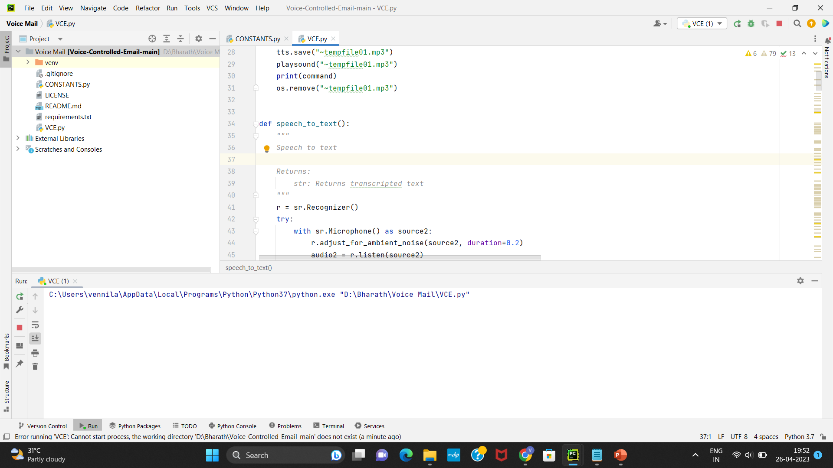

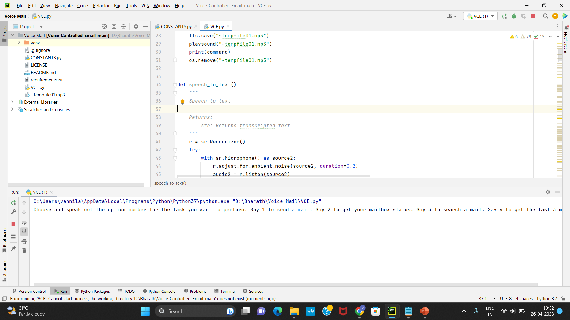

**Comparison of Existing and Proposed System**

|  |  |  |
| --- | --- | --- |
| SR NO. | EXISTING SYSTEM | PROPOSED SYSTEM |
| 1. | Less security. | High Security provided. |
| 2. | Depends on Keyboard. | The entire structure is  based on IVR- interactive  voice response. |
| 3. | Slow processing. | Faster and more efficient |
| 4. | The disables cannot use  the normal mail system. | The disables can use the  normal mail system. |
| 5. | Blind people are not  being able to interact  with the web based email  system. | They will be able to  interact with the web  based email system. |
| 6. | It is insecure in comparison to the progressive system. | It has high security, which makes it more trustable. |
| 7. | The keyboard is mandatory in this system. | Because the system is based on IVR(Interactive Voice Response), a keyboard is not required. |
| 8. | Time-consuming process(Slow execution). | It is more efficient and faster than a typical system. |
| 9. | The only person without disabilities can use the system. | Both normal and disabled people can use the system. |
| 10. | People who are blind are unable to engage with others or use the webbased email system. | The web-based email system will allow blind individuals to engage with it (using voice commands). |

**AUTHENTICATION AND SECURITY**

Users with account information such as passwords and usernames are provided due to authentication, ensuring that the user has the right password and username every time they need to sign in to the app. Therefore, this data should be stored in a database for future comparison. For identification, we will apply the control system to the user. Keeping a password straight may be dangerous: Keeping a password straight can be dangerous and a simple and easy way to keep the password simple and show them how to create a table in the database. When the user login request arrives, the server will be called in to see the live load to store the username and password. This information will then be redirected to the password stored in the database. Finally, if the game is successful, the user will be able to access the app. Only passwords stored in plain text can be dangerous and will remain open to attack. With cybercrime, the government steals passwords, and you can block the account. However, one way to save it is to save it by converting it into a non-convertible form and a real password. This process is called hashing.

**Future Scope**

There is wide future scope of this system many enhancements can be done in the system such as including different languages, including functionality of accessing the deleted mails and spam mails. Also, this system can be enhanced such that it can also send attachments which are

more beneficial for visually challenged people.

This system can be made available to all regional people who are not educated enough and inclusion of different languages will make this system easily accessible. Furthermore sign language system can also be integrated with the system to make the system more scalable and robust.

**Conclusion**

In our Project we proposes a system that will be beneficial for society by allowing disable people also to grow along with society. This project makes visually challenged people able enough to be part of growing digital India by allowing them to communicate via internet and also making life of such people much easier. This system overcomes many drawbacks that were faced by visually challenged people such as sending and receiving emails. Success of this project can make an impact on developers motivating them to make something useful that can help visually challenged or blind people.

we have proposed a system which will help the visually impaired people to access email services efficiently. This system will help overcome the drawbacks that were earlier faced by the blind people in accessing emails. We have eliminated the using of keyboard shortcuts along with screen readers which will help reducing the cognitive load of remembering keyboard shortcuts. Also, any naive user who does not know the location of keys on the keyboard need not worry as keyboard usage eliminated. The user only needs to follow the instructions given by the IVR and use mouse clicks accordingly to get the respective services offered.

**References**

1. Parkhi Bhardwaj, Gunjan Sethi Voice Based E-mail System for Visually Impaired: A ReviewInternational Research Journal of Engineering and Technology (IRJET) on December, volume 12Posted: 2020

2. John Klensin, ;, Ned Freed, ; Marshall, T Rose; Einar, A Stefferud, Dave Crocker SMTP Service Extensions. IETFPosted: 1995-11

3. K Jayachandran, P Anbunami Voice Based Email for Blind People

published in International Journal of Engineering and TechnologyPosted: 2018

4. Carmel Mary, Belinda, Rupavathy N Mahalakshmi, N Voice based e-mail System for Visually Impaired published in International Journal of Engineering and TechnologyPosted: 2018

5. A Mamatha, V Jade, J Saravana, A Purshotham, A V Suhas Voice Based E-mail System for Visually Impaired International Journal of Research in EngineeringPosted: 2020

6. A Belekar, S Sunka, N Bhawar, S BagadeVoice Based E-mail for The Visually Impaired

7. Al Smadi, Takialddin, et al. "Artificial intelligence for speech recognition based on neural networks." Journal of Signal and Information Processing 6.02 (2015): 66.

9. Lazar, Jonathan, et al. "What frustrates screen reader users on the web: A study of 100 blind users." International Journal of human-computer

interaction 22.3 (2007): 247-269.

10. December, John. "Units of analysis for Internet

communication." Journal of Computer-Mediated Communication 1.4

(1996): JCMC143.

11. Pathan, Naziya, et al. "V-Mail (Voice Based E-Mail Application)."

(2019).

12.Symons, Gary Mark, and Kirk David Symons. "Digital media editing

interface using a supercursor for selecting media clips for editing." U.S.

Patent No. 8,527,879. 3 Sep. 2013.

13. Shabana, T., et al. "Voice based email system for blinds." International

Journal of Advance Foundation And Research In Science & Engineering

(IJAFRSE) Volume 1 (2015).

14. Al Smadi, Takialddin, et al. "Artificial intelligence for speech

recognition based on neural networks." Journal of Signal and

Information Processing 6.02 (2015): 66.

15. Senders, Joeky T., et al. "Natural and artificial intelligence in

neurosurgery: a systematic review." Neurosurgery 83.2 (2018):

181-192.

16. Collobert, Ronan, et al. "Natural language processing (almost) from

scratch." Journal of machine learning research 12.Aug (2011): 2493-2537.

17. G. O. Young, “Synthetic structure of industrial plastics (Book style with

paper title and editor),” in Plastics, 2nd ed. vol. 3, J. Peters, Ed. New York: McGraw-Hill, 1964, pp. 15–64.

18. The Radicati website Email Statistics Report, 2014-2018

Available:http://www.radicati.com/wp/wpcontent/uploads/2014/01/Em

ailStatisticsReport-20142018-Executive-Summary.pdf.

19. Ingle, Pranjal, Harshada Kanade, and Arti Lanke. "Voice based e-mail

System for Blinds." International Journal of Research Studies in

Computer Science and Engineering (IJRSCSE) (2016): 25-30.

20. Isewon, Itunuoluwa, O. J. Oyelade, and O. O. Oladipupo. "Design and

implementation of text to speech conversion for visually impaired

people." International Journal of Applied Information Systems 7.2

(2012): 26-30.

21. Shakhovska, N., O. Basystiuk, and K. Shakhovska. "Development of the

speech-to-text chatbot interface based on Google API." CEUR

Workshop Proceedings. Vol. 2386. 2019.

22. https://www.juniper.net/documentation/en_US/junos/topics/concept/ip

sec-authentication-solutions.html.

23. Arlinghaus, Robert, et al. "Understanding the complexity of

catch-and-release in recreational fishing: an integrative synthesis of

global knowledge from historical, ethical, social, and biological

perspectives." Reviews in Fisheries Science 15.1-2 (2007): 75-167.

24. Cole, Ron, et al. "The challenge of spoken language systems: Research

directions for the nineties." IEEE transactions on Speech and Audio processing 3.1 (1995): 1-21.